**UNIT – I**

**SYSTEMS OF SANITATION:**

1. **CONSERVANCY SYSTEM:**

This is an old system in which various types of wastes, such as night soil, garbage etc. are collected separately in vessels or deposited in pools or pits and then removed periodically at least once in 24 hours. The system is also known as the dry system. The following are the methods of collection of various types of wastes in the system.

1. **Night soil:**

* Night soils or human excreta in lavatories, privies or cesspools etc. is collected separately in pans or pails and carried on heads of sweepers to a central place from where it is transported in bullock carts or motor vans to a place away from the town for its final disposal. Normally, it is buried into ground, in trenches, to give excellent manure in one or two years.

1. **Garbage:**

* Garbage is collected separately, in dust bins and conveyed on hand carts or motor van once or twice is a day. It may consists of waste matter of both non-combustible as well as combustible type. The two are therefore sorted out. Garbage disposal methods include the open dump, incineration, dumping into sanitary fill, fermentation or biological digestion. Incineration, if properly controlled, is satisfactory for burning Combustible refuse.

1. **Sullage and storm water:**

* Sullage and storm water are collected and conveyed separately in closed or open gutters. The liquid and semi-liquid mass of filth which frequently overflow the receptacles in privies is swept away by the sweepers to drain from the privies, which carry it to drains carrying sullage and storm water, along the public lanes or streets.
* There was a time when the conservancy system was favoured and the water carriage system was opposed by European chemists, physicians and agriculturists because of a fear of contamination of the soil by leakage from the sewers and the possible pollution of bodies of water receiving the sewage and possible nuisance where sewage was distributed on land However, in India, the conservancy system is still on vogue in all the villages and small towns. Only a few cities have the water carriage system.

**Disadvantages of conservancy system:**

1. **Hygiene and sanitary aspect:**

* The conservancy system is highly unhygienic and cause insanitary conditions since the excreta starts decomposing within few hours of its production.
* Even if it is assumed that cleaning will take place twice in a day, the excreta remaining in the previes will emit bad smell and will give rise to fly nuisance.

1. **Transportation aspect:**Transportation of night soil takes place in open carts through streets and other crowded localities. This is highly undesirable.
2. **Labour aspect:**

* The working of the system depends entirely on the mercy of labour (sweepers). If they go on strike even for one day for any reason whatsoever, the previes can not be used because of foul smell. The whole locality will smell very badly.

1. **Building design aspect:**

* The lavatories or previes are to be located outside the house and slightly away from the main building. The compact design is therefore not possible.

1. **Conditions of drains:**

* Insanitation may be there due to carriage of sullage through open drains laid in the streets.

1. **Human aspect:**

* In the present day world, when man has progressed much, it is highly humiliating to ask human beings to transport night soil in pails on their heads.

1. **Risk of epidemic:**

* Due to improper or careless disposal of night soil, there are more chances of outbreak of epidemic

1. **Pollution problem:**

* The liquid wastes from lavatories etc, during their washing, may soak in the ground, thus contaminating the soil. If the ground water is at a shallow depth, it may also be polluted due to percolation of waste water.

1. **Cost consideration:**

* Though the system is quite cheap in the beginning. Its maintenance and establishment costs (i.e. recurring expenditure) are very high.

1. **Disposal land requirement:**

* The system requires considerable land for the disposal of sewage.

1. **WATER CARRIAGE SYSTEM:**

* Collection, conveyance, disposal of waste carried with the help of water. Water is the main substance, so it is called as water carriage system.
* Waste is mixed with water (large quantity), then conveyed through designed sewers and then disposed off after treatment.
* Sewage contains 99.9% of water and 0.1% of solid waste.
* Specially designed water closets are used which are flushed with 5 – 10 lit of water after usage. Excreta can easily flushed away. Sullage led to sewers.
* Sewer is laid longitudinally so that flow takes place under gravity and proper velocity is maintained to keep the sewer clean.
* It should be noted that garbage is collected separately and conveyed in the same manner as done in conservancy system, to avoid sewer clogging.
* The system requires large initial cost of installation and it requires large quantity of water also to create efficient flow conditions.
* If the financial conditions of people are poor, it may be difficult to adopt this system.

**Advantages of Water Carriage System:**

1. **Hygiene and sanitary aspect:**

* The system is very hygienic since the night soil and other waste water is conveyed through closed conduits which are not directly exposed to the atmosphere. There is no bad smell because of continuous flow.

1. **Epidemic aspect:**

* There are no chances of outbreak or epidemic because flies and other insects do not have direct access to the sewage.

1. **Pollution aspect:**

* The liquid wastes etc. are directly conveyed through the sewers and therefore there are no chances of the waste water being soaked in the ground thus contaminating the soil.
* The waste water does not percolate down to join the ground water. There are no chances of pollution of water of wells in individual houses if any.

1. **Compactness in design:**

* Since the latrines are flushed after every use, excreta does not remain and there are no foul smells. The lavatories can therefore be attached to the living and bed rooms. This permits a compact design. The lavatories can be accommodated in any part of the house.

1. **Labour aspect:**

* The labour required for the operation and maintenance is extremely small. in fact, the functioning of the system is practically automatic except for the operation of certain pumps etc. Therefore, there is no labour problem.

1. **Treatment aspect:**

* The system permits the use of modern methods of treatment of the sewerage collected through the sewers. The treated wastewater and sewage can be safely disposed off without any risk.

1. **Land disposal requirements:**

* Because of treatment facilities, the land required for the disposal of the treated wastewater is very much smaller than that required for the conservancy system.

1. **Cost consideration:**

* Though the initial cost of installation of the system is very high, the running costs are very small since manual labour a very much reduced.

**Sewerage:**

The term sewerage refers the infrastructure which includes device, equipment and appurtenances for the collection, transportation and pumping of sewage, but excluding works for the treatment of sewage. Basically it is a science of collecting and carrying sewage by water carriage system through sewers.

**SYSTEMS OF SEWERAGE:**

For safe disposal of the sewage generated from a locality efficient collection, conveyance, adequate treatment and proper disposal of treated sewage is necessary.

To achieve these following conditions should be satisfied:

* Sewage should not pollute the drinking water source, either surface or ground water or water bodies that are used for bathing or recreational purposes.
* The untreated sewage during conveyance should not be exposed so as to have access to human being or animals and should not give unsightly appearances or odour nuisance and should not become a place for breeding flies.
* It should not cause harm to public health and adversely affect the receiving environment.

The systems of sewerages can be of following three types.

1. **Combined system:**

In combined system along with domestic sewage, the run-off resulting from storms is carried through the same sewers of sewerage system.

**Advantages of separate system:**

1. In an area where rainfall is spread throughout a year, there is no need of flushing of

sewers, as self-cleansing velocity will developed due to more quantity because of addition of storm water.

1. Only one set of pipe will be required for house plumbing.
2. In congested areas it is easy to lay only one pipe rather than two pipes as required in

other systems.

**Disadvantages of separate system:**

1. Not suitable for the area with small period of rainfall in a year, because dry weather

flow will be small due to which self-cleansing velocity may not develop in sewers, resulting in silting.

1. Large flow is required to be treated at sewage treatment plant before disposal, hence resulting in higher capital and operating cost of the treatment plant.
2. When pumping is required this system is uneconomical.
3. During rains overflowing of sewers will spoil public hygiene.

**2. Separate System:**

In separate system, separate conduits are used, one carrying sewage and other carrying storm water run-off. The storm water collected can be directly discharged into the water body since the run-off is not as foul as sewage and no treatment is generally provided. Whereas, the sewage collected from the city is treated adequately before it is discharged into the water body or used for irrigation to meet desired standards. Separate system is advantageous and economical for big towns.

**Advantages of separate system:**

* As sewage flows in separate pipe, hence the quantity to be treated at sewage treatment plant is small, resulting in economy of treatment.
* This system may be less costly as only sanitary sewage is transported in closed conduit and storm water can be collected and conveyed through open drains.
* When pumping is required during disposal, this system is economical due to less flow.

**Disadvantages of separate system:**

* Self-cleansing velocity may not be developed at certain locations in sewers and hence flushing of sewers may be required.
* This system requires laying two sets of pipe, which may be difficult in congested area.
* This system will require maintenance of two sets of pipelines and hence maintenance cost is more.

**4. Partially separate system:**In this system part of the storm water especially collected from roofs and paved courtyards of the buildings is admitted in the same drain along with sewage from residences and institutions, etc. The storm water from the other places is collected separately using separate conduits.

**Advantages of partially separate system**

* Economical and reasonable size sewers are required.
* Work of house plumbing is reduced as rain water from roofs, sullage from baths and kitchen, etc. are combined with discharge from water closets.
* Flushing of sewers may not be required as small portion of storm water is allowed to enter in sanitary sewage.

**Disadvantages of partially separate system:**

* Increased cost of pumping as compared to separate system at treatment plants and intermediate pumping station wherever required.
* In dry weather self-cleansing velocity may not develop in the sewers.

**Sources of wastewater:**

1. Domestic wastewater
2. Industrial wastewater
3. Infiltration
4. Storm water

**Sources of Sanitary Sewage:**

* Water supplied by water authority for domestic usage, after desired use is discharged in to sewers as sewage.
* Water supplied to the various industries for various industrial processes by local authority. Some quantity of this water after use in different industrial applications is discharged as wastewater.
* The water supplied to the various public places such as, schools, cinema theaters, hotels, hospitals, and commercial complexes. Part of this water after desired use joins sewers as wastewater.
* Water drawn from wells by individuals to fulfil domestic demand. After uses this water is discharged in to sewers.
* The water drawn for various purposes by industries, from individual water sources such as, wells, tube wells, lake, river, etc. Fraction of this water is converted in to wastewater in different industrial processes or used for public utilities within the industry generate wastewater. This is discharged in to sewers.
* Infiltration of ground water into sewers through leaky joints.
* Entrance of rainwater in sewer lines during rainy season through faulty joints or cracks in sewers.

**Sewage and storm water estimation:**

**Estimation of storm water:**

Storm water can be estimated by two methods. They are:

1. Rational method
2. Empherical method
3. **Rational method:**

Storm water is determined by

Q = $\frac{CiA}{360}$

Where Q = Quantity of storm water (m3/sec)

C = Co-efficient of runoff

i = Intensity of rainfall in mm/hr

A = drainage area in hectare

**Area:**

Area can be found by taking city map and tentative arrangement of sewer lines are showed, whole area is divided into zones and then area is calculated.

**Runoff Co-efficient:**

* Whole rainfall falls on ground doesn’t reaches the sewer lines, some water will percolates, evaporates, some portion stored in ponds or ditches and after that remaining water reaches the sewers and drains.
* After continuous rainfall for some time, after filling of ponds, ditches, atmosphere becomes very saturated. The runoff co-efficient mainly depends upon characteristics of soil.
* If every locality consists of different types of surfaces areas, overall runoff co-efficient can be calculated by

C = $\frac{A1+A2+A3+----+AnCn}{A1+A2+A3+---+An}$ = $\frac{∑AC}{∑A}$

**Empherical formulae for intensity of rainfall:**

Based on storm frequency, duration, intensity of rainfall changes. Rainfall intensity can get by records. In case where rainfall records are not available.

1. **General formula:**

i = $\frac{25.4 a}{t+b}$

where i = Intensity of rainfall

t = Duration of storm (mm)

a & b are constants

According to the ministry of health (U.S.A)

a = 30 b = 10 when storm duration is 5 – 20 min

a = 40 b = 20 when storm duration is 20 – 100 min

1. **For localities where rainfall is frequent:**

i = $\frac{3430}{t+18}$

Adopted for areas having heavy frequent rainfall. It gives rainfall of intensity which occur once in 5 years.

1. **For storms occurring once in 10 years:**

i = $\frac{180}{\sqrt{t}}$

1. **For storms occurring once in year:**

i = $\frac{150}{t^{0.625}}$

1. **Kuichling’s formula:**

i = $\frac{2667}{t+20}$ (For storms occurring once in 10 years)

i = $\frac{3048}{t+20}$ (For storms occurring once in 5 years)

1. **Empherical formula method:**

For determining runoff for very large areas gradually empherical formulae are used. All the empherical formulae can be applied only under certain specific conditions such as slope of land, imperviousness, rate of rainfall etc.,

1. Burkli – Ziegler’s formula (Switzerland)

Q = $\frac{CiA}{141.58}$ $\sqrt[4]{\frac{S}{A}}$

1. Mc. Math’s formula ( Used in U.S.A)

Q = $\frac{CiA}{148.35}$ $\sqrt[5]{\frac{S}{A}}$

1. Fuller’s formula

Q = $\frac{C.M^{0.8}}{141.58}$

1. Fanning’s formula:

Q = 12.8 $M^{\frac{5}{8}}$

1. Talbot’s formula

Q = 22.4 $M^{\frac{1}{4}}$

Where Q = Quantity of storm water (m3/sec)

C = Co-efficient of runoff

i = Intensity of rainfall in cm/hr

A = Drainage area in hectare

S = Slope of area in m/1000m

M = Drainage area in Km2

**Estimation of storm water:**

1. **Dry Weather Flow**

Dry weather flow is the flow that occurs in sewers in separate sewage system or the flow that occurs during dry seasons in combined system. This flow indicates the flow of sanitary sewage. This depend upon the rate of water supply, type of area served, economic conditions of the people, weather conditions and infiltration of ground water in the sewers, if sewers are laid below ground water table.

1. **Evaluation of Sewage Discharge**

Correct estimation of sewage discharge is necessary; otherwise sewers may prove inadequate resulting in overflow or may prove too large in diameter, which may make the system uneconomical and hydraulically inefficient. Hence, before designing the sewerage system it is important to know the discharge / quantity of the sewage, which will flow in it after completion of the project and at the end of design period.

**Apart from *accounted water supplied* by water authority that will be converted to wastewater, following quantities are considered while estimating the sewage quantity:**

**a. Addition due to unaccounted private water supplies**

People using water supply from private wells, tube wells, etc. contribute to the wastewater generation more than the water supplied by municipal authority. Similarly, certain industries utilize their own source of water. Part of this water after desired uses is converted into wastewater and ultimately discharged in to sewers. This quantity can be estimated by actual field observations.

**b. Addition due to infiltration**

This is additional quantity due to groundwater seepage in to sewers through faulty joints or cracks formed in the pipes. The quantity of the water depends upon the height of the water table above the sewer invert level. If water table is well below the sewer invert level, the infiltration can occur only after rain when water is moving down through soil. The quantity of the water entering sewers depends upon the permeability of the ground soil and it is very difficult to estimate.

Storm water drainage may also infiltrate into sewers. This inflow is difficult to calculate. Generally, no extra provision is made for this quantity. This extra quantity can be taken care of by extra empty space left at the top in the sewers, which are designed for running ¾ full at maximum design discharge. The quantity of the water entering sewers depends upon the permeability of the ground soil and it is very difficult to estimate. While estimating the design discharge, following suggested discharge can be considered.

Table:Suggested estimates for ground water infiltration for sewers laid below ground water table (CPHEEO) Manual, 1993)

|  |  |  |
| --- | --- | --- |
| **Unit** | **Minimum** | **Maximum** |
| L/ha.d | 5000 | 50000 |
| L/Km.d | 500 | 5000 |
| L/day/Manhole | 250 | 5000 |

**c. Subtraction due to water losses**

The water loss, through leakage in water distribution system and house connections, does not reach consumers and hence, not appear as sewage.

**d. Subtraction due to water not entering the sewerage system**

Certain amount of water is used for such purposes, which may not generate sewage, e.g. boiler feed water, water sprinkled over the roads, streets, lawns, and gardens, water consumed in industrial product, water used in air coolers, etc.

**Net quantity of sewage:**

The net quantity of sewage production can be estimated by considering the addition and subtraction as discussed above over the accounted quantity of water supplied by water authority as below:

**Net quantity of sewage = accounted quantity of water supplied from the water works + addition due to un accounted private water supplies + addition due to infiltration - subsraction due to water infiltration - substraction due to water not entering the sewage**

Generally, 75 to 80% of accounted water supplied is considered as quantity of sewage Produced.

**Variation in Sewage Flow**

Variation occurs in the flow of sewage over annual average daily flow. Fluctuation in flow occurs from hour to hour and from season to season. The typical hourly variation in the sewage flow is shown in the below figure.

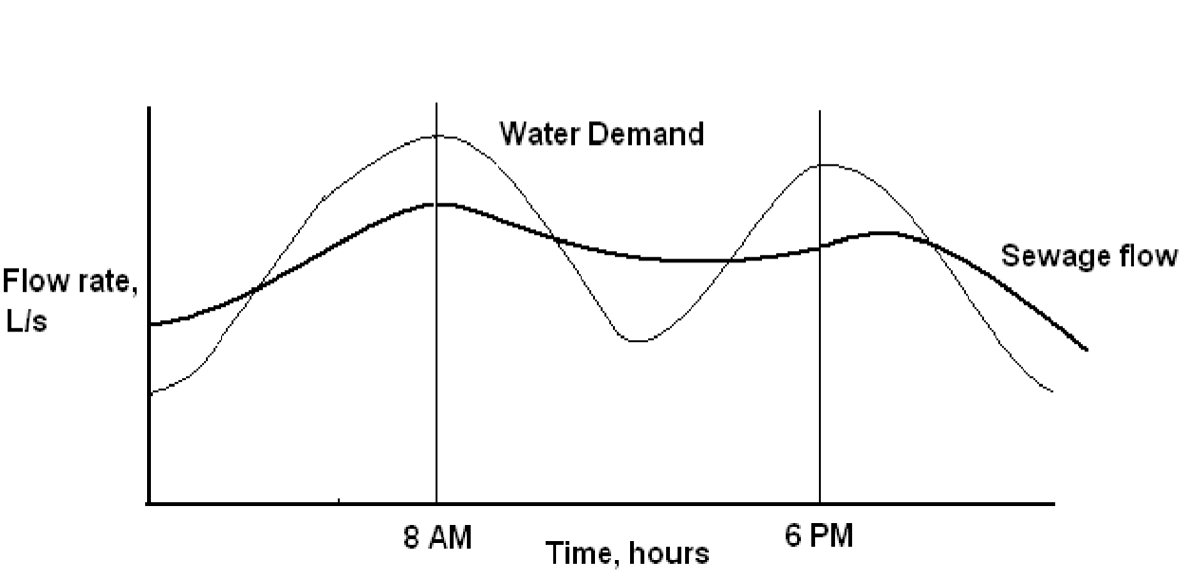

Figure: Typical hourly variations in sewage flow

If the flow is gauged near its origin, the peak flow will be quite pronounced. The peak will defer if the sewage has to travel long distance. This is because of the time required in collecting sufficient quantity of sewage required to fill the sewers and time required in travelling.

As sewage flow in sewer lines, more and more sewage is mixed in it due to continuous increase in the area being served by the sewer line. This leads to reduction in the fluctuations in the sewage flow and the lag period goes on increasing. The magnitude of variation in the sewage quantity varies from place to place and it is very difficult to predict. For smaller township this variation will be more pronounced due to lower length and travel time before sewage reach to the main sewer and for large cities this variation will be less.

For estimating design discharge following relation can be considered:

**Maximum daily flow = 2 × annual average daily flow (representing seasonal variations)**

**Maximum hourly flow = 1.5 × maximum daily flow (accounting hourly variations)**

**= Three times the annual average daily flow**

As the tributary area increases, peak hourly flow will decrease. For smaller population served (less than 50000) the peak factor can be 2.5, and as the population served increases its value reduces. For large cities it can be considered about 1.5 to 2.0. Therefore, for outfall sewer the peak flow can be considered as 1.5 times the annual average daily flow. Even for design of the treatment facility, the peak factor is considered as 1.5 times the annual average daily flow. The minimum flow passing through sewers is important to develop self cleansing velocity to avoid silting in sewers. This flow will generate in the sewers during late night hours. The effect of this flow is more pronounced on lateral sewers than the main sewers. Sewers must be checked for minimum velocity as follows:

Minimum daily flow = 2/3 Annual average daily flow

Minimum hourly flow = ½ minimum daily flow

= 1/3 Annual average daily flow

The overall variation between the maximum and minimum flow is more in the laterals and less in the main or trunk sewers. This ratio may be more than 6 for laterals and about 2 to 3 in case of main sewers.

**4.6 Design Period**

The future period for which the provision is made in designing the capacities of the various components of the sewerage scheme is known as the design period. The design period depends upon the following:

Ease and difficulty in expansion,

* Amount and availability of investment,
* Anticipated rate of population growth, including shifts in communities, industries and

commercial investments.

* Hydraulic constraints of the systems designed, and
* Life of the material and equipment.

Following design period can be considered for different components of sewage scheme.

1. Laterals less than 15 cm diameter : Full development

2. Trunk or main sewers : 40 to 50 years

3. Treatment Units : 15 to 20 years

4. Pumping plant : 5 to 10 years

**Design Discharge of Sanitary Sewage:**

The total quantity of sewage generated per day is estimated as product of forecasted population at the end of design period considering per capita sewage generation and appropriate peak factor. The per capita sewage generation can be considered as 75 to 80% of the per capita water supplied per day. The increase in population also result in increase in per capita water demand and hence, per capita production of sewage. This increase in water demand occurs due to increase in living standards, betterment in economical condition and changes in habit of people.

**HYDRAULIC DESIGN OF SEWERS:**

The sewage to be transported through sewers is mostly liquid (i.e.water), containing hardly 0.1 to 0.2 percent of solid matter in the form of organic matter, sediments and minerals. The general approach for the design of sewers is similar to the design of water mains. However, there are two differences in the designs of the sewers and of the water mains:

1. **Presence of solid matter:** Water flowing through the water mains is practically free from solid matter, while the sewage flowing through sewers contain particles of solid matter (both organic as well as inorganic). These solid particles settle at the bottom and have to be dragged during the sewage transport.
2. **Pressure:** Water in the water mains flow under pressure. Hence the water mains can be carried, within certain limits, up and down the hill or gradient.

The hydraulic gradient line lies very much above the pipe surface. On the other hand in most cases, sewers may be considered as opened channels, where in the sewage runs under gravity. The sewers seldom run full, and the H.G. line falls within the sewer.

**Hydraulic Formulae:**

The design of sewer is done of the basis of the following empherical formulae.

1. Chezy’s formula
2. Kutters’s formula
3. Bazin’s formula
4. Manning’s formula
5. Crimp and Burge’s formula
6. Hazen and William’s formula.

The factors that influence the flow of sewage in the sewers are:

1. Slope of sewer
2. Geometry of sewer
3. Roughness of interiors surface of sewer
4. Bends, transitions, obstructions
5. Flow conditions and
6. Characteristics of sewage
7. **Chezy’s formula:**

V = C $\sqrt{RS}$

Where V = Velocity of flow (m/sec.)

S *=* Hydraulic gradient or slope of the sewer

R = Hydraulic mean radius (m) = A/P

A = Area of cross-section (m2)

I = Wetted perimeter.

C = Chezy’s constant

The Chezy’s constant C is very complex in nature and it depends upon several factors such as roughness of inner surface of sewer, hydraulic mean radius, size and shape of sewer, slope etc.

C is found either by Kutter’s formula or by Bazin’s formula. Knowing the velocity of flow V from above chezy’s formula, the channel section is designed by the general fomula:

*Q* = A x *V*

Where Q = Discharge in m3/sec

1. **Kutter’s formula:**

C = $\frac{23+ \frac{0.00155}{S}+ \frac{1 }{N}}{1+\left( 23+ \frac{0.00155}{S}\right)\frac{N}{\sqrt{R}}}$

Where N = Rugosity coefficient, depends on nature of inside surface of the sewer

For CC pipes of dia. 600 mm and above, N = 0.013 may be adopted

1. **Bazin’s formula:**

**C = $\frac{157.6}{1.81+ \frac{K}{\sqrt{R}}}$**

Where K = Bazin’s constant

1. **Manning’s formula:**

V = $\frac{1}{N}$ R2/3 S1/2

1. **Crimp and Bruge’s formula:**

V = 83.47 R2/3 S1/2

Comparing with manning’s formula

V = 83.47 R2/3 S1/2 = R2/3 S1/2 / N

Which gives N = 1/83.47 = 0.012

(manning’s formula becomes Crimp and Bruge’s formula when N = 0.012)

For circular pipe, R = $\frac{A}{P}$ = $\frac{\frac{π}{4}D^{2}}{πD}$ = $\frac{D}{4}$

V = 83.47 R2/3 S1/2 = 83.47[ ]2/3 S1/2

Q = A x V

Q = 26.02 D8/3 S1/2

1. **Hazen and william’s formula:**

V = 0.85 C R0.63 S0.54

**Minimum Velocity of Flow:**

* The sewage flowing through a sewer contains organic as well as inorganic solid matter which remains suspended as the sewage flow. In order to keep the solid matter in suspended form, a certain minimum velocity of flow is required. Otherwise the solid particles will settle in the sewer, resulting in its clogging. Such a minimum velocity is known as self-cleansing velocity(VS).
* A self-cleansing velocity may be defined as that velocity at which the solid particles will remain in suspension, without settling at the bottom at the sewer. Also it is that velocity at which even the scour of the deposited particles or it given size will taken place.

VS =

Where VS = self - cleansing velocity.

β = Characteristics of solids flowing in the sewage, in suspension.

This value of β may be taken as 0.04 for initiating scour of clean grit to 0.8 for full removal of sticky grit. Actual magnitude of *k* has to be found from experiments.

f = Darcy-Weisbatch friction factor, the common value of which may be taken as 0.03.

$G_{S}$ =Specific gravity of sediments/solids flowing in the sewage. Its value may range from 2.65 for inorganic sediments to 1.2 to for organic sediments.

g = gravitational acceleration constant.

d,=diameter of solid particles, to be carried by the liquid.

**Maximum Velocity of Flow:**

Though the minimum velocity of flow of sewage should be equal to the self-cleansing velocity so that particles do not settle and stick to the invert, there is also some upper limit of velocity of flow so that the interior surface of the newer is not damaged due to wear.

At higher velocity the flow becomes turbulent resulting in continuous abrasion of the interior surface of the sewer, by the suspended particles. Hence maximum velocity of flow is also limited. The maximum velocity at which no such scouring action or abrasion takes place is known as non-scouring velocity.

**Hydraulic elements of circular sewer:**

1. **Sewer at running full condition:**

Let D be the internal dia. of sewer.

Area of cross – section A = $\frac{π}{4}D^{2}$

Wetted perimeter P = πD

Hydraulic mean depth R = A/P = D/4

1. **Circular sewer running partially full:**

D

d

θ

1. **Depth**:

d = $\frac{D}{2}- \frac{D}{2}Cos\frac{θ}{2}$

= $\frac{D}{2}(1-cos\frac{θ}{2})$

Proportional depth = $\frac{d}{D}= \frac{1}{2}( 1-cos\frac{θ}{2})$

1. **Area:**

a = $\frac{π}{4}D^{2}$ [ $\frac{θ}{360°}- \frac{sinθ}{2π}$]

Proportional area $\frac{a}{A} =$ [ $\frac{θ}{360°}- \frac{sinθ}{2π}$]

1. **Wetted perimeter:**

p = $π$ D $\frac{θ}{360°}$

Proportional perimeter = $\frac{p}{P}$ $\frac{θ}{360°}$

1. **H.M.D:**

r = $\frac{D}{4}$ [1 - $\frac{360°\sin{θ}}{2πθ}$]

Proportional H.M.D $\frac{r}{R}=$ [1 - $\frac{360°\sin{θ}}{2πθ}$]

1. **Velocity of flow:**

V = $\frac{1}{N}$ R2/3 S1/2

Proportional velocity 2/3

1. **Discharge:**

q = a x v

Taking N/n = 1.0

Proportionate discharge )2/3

**DIFFERENT MATERIALS USED FOR SEWERS:**

1. **Asbestos Cement Sewers**

* These are manufactured from a mixture of asbestos fibers, silica and cement. Asbestos fibers are thoroughly mixed with cement to act as reinforcement.
* These pipes are available in size 10 to 100 cm internal diameter and length up to 4.0 m.
* These pipes can be easily assembled without skilled labour with the help of special Coupling, called ‘Ring Tie Coupling’ or Simplex joint.
* The pipe and joints are resistant to corrosion and the joints are flexible to permit 12° deflection for curved laying.
* These pipes are used for vertical transport of water. For example, transport of rainwater from roofs in multi-storied buildings, for transport of sewage to grounds, and for transport of less foul sullage i.e., wastewater from kitchen and bathroom.

**Advantages**

* These pipes are light in weight and hence, easy to carry and transport.
* Easy to cut and assemble without skilled labour.
* Interior is smooth (Manning n = 0.011) hence, can make excellent hydraulically efficient sewer.
* **Disadvantages**
* These pipes are structurally not very strong.
* These are susceptible to corrosion by sulphuric acid. When bacteria produces H2S, in

presence of water, H2SO4 can be formed.

1. **Plain Cement Concrete or Reinforced Cement Concrete**

* Plain cement concrete (1: 1.5: 3) pipes are available up to 0.45 m diameter and reinforcement cement pipes are available up to 1.8 m diameter. These pipes can be cast in situ or precast pipes.
* Precast pipes are better in quality than the cast in situ pipes. The reinforcement in these pipes can be different such as single cage reinforced pipes, used for internal pressure less than 0.8 m, double cage reinforced pipes used for both internal and external pressure greater than 0.8 m, elliptical cage reinforced pipes used for larger diameter sewers subjected to external pressure and hume pipes with steel shells coated with concrete from inside and outside. Nominal longitudinal reinforcement of 0.25% is provided in these pipes.

**Advantages of concrete pipes**

* Strong in tension as well as compression.
* Resistant to erosion and abrasion.
* They can be made of any desired strength.
* Easily moulded, and can be in situ or precast pipes.
* Economical for medium and large sizes.
* These pipes are available in wide range of size and the trench can be opened and back filled rapidly during maintenance of sewers.

**Disadvantages**

* These pipes can get corroded and pitted by the action of H2SO4.
* The carrying capacity of the pipe reduces with time because of corrosion.
* The pipes are susceptible to erosion by sewage containing silt and grit.
* The concrete sewers can be protected internally by vitrified clay linings. With protection lining they are used for almost all the branch and main sewers. Only high alumina cement concrete should be used when pipes are exposed to corrosive liquid like sewage.

1. **Vitrified Clay or Stoneware Sewers**

These pipes are used for house connections as well as lateral sewers. The size of the pipe available is 5 cm to 30 cm internal diameter with length 0.9 to 1.2 m. These pipes are rarely manufactured for diameter greater than 90 cm. These are jointed by bell and spigot flexible compression joints.

**Advantages**

* Resistant to corrosion, hence fit for carrying polluted water such as sewage.
* Interior surface is smooth and is hydraulically efficient.The pipes are highly impervious.
* Strong in compression.
* These pipes are durable and economical for small diameters.
* The pipe material does not absorb water more than 5% of their own weight, when immersed in water for 24 h.

**Disadvantages**

* Heavy, bulky and brittle and hence, difficult to transport.
* These pipes cannot be used as pressure pipes, because they are weak in tension.
* These require large number of joints as the individual pipe length is small.

1. **Brick Sewers**

* This material is used for construction of large size combined sewer or particularly for storm water drains. The pipes are plastered from outside to avoid entry of tree roots and ground water through brick joints.
* These are lined from inside with stone ware or ceramic block to make them smooth and hydraulically efficient. Lining also make the pipe resistant to corrosion.

1. **Cast Iron Sewers**

* These pipes are stronger and capable to withstand greater tensile, compressive, as well as bending stresses. However, these are costly. Cast iron pipes are used for outfall sewers, rising mains of pumping stations, and inverted siphons, where pipes are running under pressure.
* These are also suitable for sewers under heavy traffic load, such as sewers below railways and highways. They are used for carried over piers in case of low lying areas. They form 100% leak proof sewer line to avoid ground water contamination.
* They are less resistant to corrosion hence, generally lined from inside with cement concrete, coal tar paint, epoxy, etc. These are joined together by bell and spigot joint. IS:1536 -1989 and IS:1537-1976 provides the specifications for spun and vertically cast pipes, respectively.

1. **Steel Pipes**

* These are used under the situations such as pressure main sewers, under water crossing, bridge crossing, necessary connections for pumping stations, laying pipes over self- supporting spans, railway crossings, etc. They can withstand internal pressure, impact load and vibrations much better than CI pipes. They are more ductile and can withstand water hammer pressure better.
* These pipes cannot withstand high external load and these pipes may collapse when negative pressure is developed in pipes. They are susceptible to corrosion and are not generally used for partially flowing sewers. They are protected internally and externally against the action of corrosion.

1. **Ductile Iron Pipes**

* Ductile iron pipes can also be used for conveying the sewers. They demonstrate higher capacity to withstand water hammer. The specifications for DI pipes is provided in IS:12288-1987.
* The predominant wall material is ductile iron, a spheroidized graphite cast iron. Internally these pipes are coated with cement mortar lining or any other polyethylene or poly wrap or plastic baggging/ sleeving lining to inhibit corrosion from the wastewater being conveyed, and various types of external coatings are used to inhibit corrosion from the environment.
* Ductile iron has proven to be a better pipe material than cast iron but they are costly. Ductile iron is still believed to be stronger and more fracture resistant material; like most ferrous materials, it is susceptible to corrosion.
* A typical life expectancy of thicker walled pipe could be up to 75 years, however with the current thinner walled ductile pipe the life could be about 20 years in highly corrosive soils without a corrosion control program like cathodic protection.

1. **Plastic sewers (PVC pipes)**

* Plastic is recent material used for sewer pipes. These are used for internal drainage works in house.
* These are available in sizes 75 to 315 mm external diameter and used in drainage works. They offer smooth internal surface.
* The additional advantages they offer are resistant to corrosion, light weight of pipe, economical in laying, jointing and maintenance, the pipe is tough and rigid, and ease in fabrication and transport of these pipes.

1. **High Density Polythylene (HDPE) Pipes**

* Use of these pipes for sewers is recent development. They are not brittle like AC pipes and other pipes and hence hard fall during loading, unloading and handling do not cause any damage to the pipes.
* They can be joined by welding or can be jointed with detachable joints up to 630 mm

1. **Glass Fiber Reinforced Plastic Pipes**

* This martial is widely used where corrosion resistant pipes are required. GRP or FRP can be used as a lining material for conventional pipes to protect from internal or external corrosion.
* It is made from the composite matrix of glass fiber, polyester resin and fillers. These pipes have better strength, durability, high tensile strength, low density and high corrosion resistance.
* These are manufactured up to 2.4 m diameter and up to 18 m length (IS:12709-1989).

1. **Lead Sewers**

* They are smooth, soft and can take odd shapes.
* This pipe has an ability to resist sulphide corrosion.
* However, these pipes are very costly.
* These are used in house connection.

**SHAPES OF SEWER PIPES**

Sewers are generally circular pipes laid below ground level, slopping continuously towards the outfall. These are designed to flow under gravity. Shapes other than circular are also used.

Other Shapes used for sewers are shown in fig :

a. Standard Egg-shaped sewer

b. New egg-shaped sewer

c. Horse shoe shaped sewer

d. Parabolic shaped sewer

e. Semi-elliptical section

f. Rectangular shape section

g. U-shaped section

h. Semi-circular shaped sewer

i. Basket handled shape sewer

* Standard egg-shaped sewers, also called as ovoid shaped sewer, and new or modified egg-shaped sewers are used in combined sewers. These sewers can generate self cleansing velocity during dry weather flow.
* Horse shoe shaped sewers and semi-circular sections are used for large sewers with heavy discharge such as trunk and outfall sewers.
* Rectangular section is used for conveying storm water.
* U-shaped section is used for larger sewers and especially in open cuts. Other sections of the sewers have become absolute due to difficulty in construction on site and non-availability of these shapes readily in market.

 

**(a) Standard Egg Shaped Sewer (b) New/ Modified Egg shaped Sewer**

 

**(c) Horse shoe sewer section (d) Parabolic section**

 

**(E) Semi-elliptical Section (F) Rectangular Sewer**

 

**(g) U-shaped section (h) Semi-circular Section**



**(i) Basket-Handle Section**

**SEWER APPURTENANCES:**

Sewer appurtenances are devices necessary in addition to pipes and conduits for the pipes functioning of any complete system of sanitary, storm or combined sewers. They include structures and devices such as various types of manholes, lamp holes, gully traps, intercepting chambers, flush tanks, ventilation shafts, catch basins, street inlets, regulators, siphons, grease traps, side float weir, leaping weir, and venture-flumes and out fall structures.

1. **CATCH BASINS**

Catch basins are provided to stop the entry of heavy debris present in the storm water into the sewers. However, their use is discouraged because of the nuisance due to mosquito breeding apart from posing substantial maintenance problems. At the bottom of the basin space is provided for the accumulation of impurities. Perforated cover is provided at the top of the basin to admit rain water into the basin. A hood is provided to prevent escape of sewer gas.



**Figure: Catch Basin**

# **Manholes**

The manhole is masonry or R.C.C. chamber constructed at suitable intervals along the sewer lines, for providing access into them. Thus, the manhole helps in inspection, cleaning and maintenance of sewer. These are provided at every bend, junction, change of gradient or change of diameter of the sewer. The sewer line between the two manholes is laid straight with even gradient. For straight sewer line manholes are provided at regular interval depending upon the diameter of the sewer. The spacing of manhole is recommended in IS 1742-1960. For sewer up to 0.3 m diameter or sewers which cannot be entered for cleaning or inspection the maximum spacing between the manholes recommended is 30 m, and 300 m spacing for pipe greater than 2.0 m diameter. A spacing allowance of 100 m per 1 m diameter of sewer is a general rule in case of very large sewers (CPHEEO, 1993). The internal dimensions required for the manholes are provided in Table Below (CPHEEO, 1993). The minimum width of the manhole should not be less than internal diameter of the sewer pipe plus 150 mm benching on both the sides.

**Table :** Spacing of Manholes

|  |  |
| --- | --- |
| **Pipe Diameter** | **Spacing** |
| Small sewers | 45 m |
| 0.9 to 1.5 m | 90 to 150 m |
| 1.5 to 2.0 m | 150 to 200 m |
| Greater than 2.0 m | 300 m |

**Table :** The minimum internal dimensions for manhole chambers

|  |  |
| --- | --- |
| **Depth of sewer** | **Internal dimensions** |
| 0.9 m or less depth | 0.90 m x 0.80 m |
| For depth between 0.9 m and 2.5 m | 1.20 m x 0.90 m, 1.2 m dia. for circular |
| For depth above 2.5 m and up to 9.0 m | For circular chamber 1.5 m dia. |
| For depth above 9.0 m and up to 14.0 m | For circular chamber 1.8 m dia. |

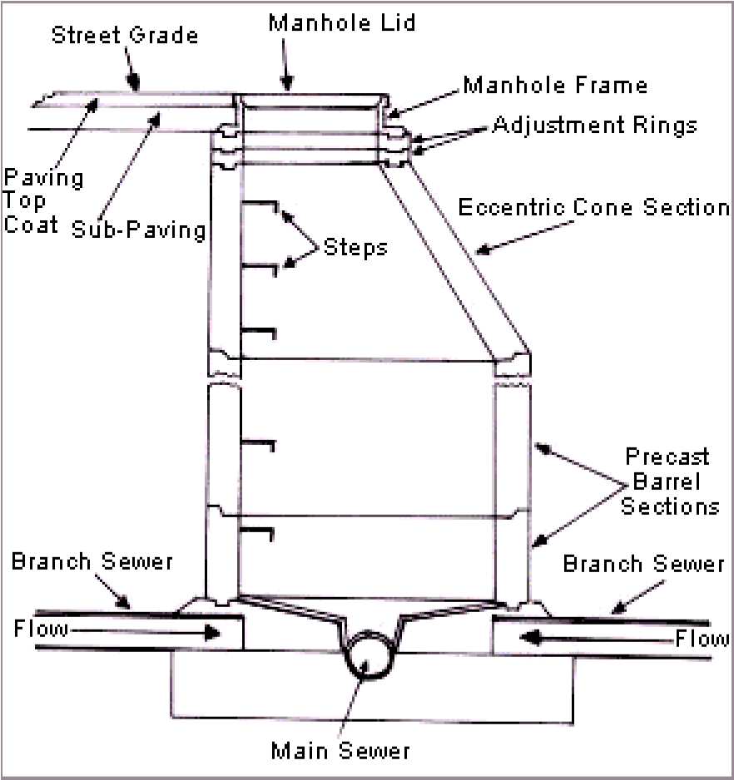

## Figure: Manhole

**Depending upon the depth the manholes can be classified as:**

(a) Shallow Manholes,

(b) Normal Manholes, and

(c) Deep Manholes

***Shallow Manholes***: These are 0.7 to 0.9 m depth, constructed at the start of the branch seweror at a place not subjected to heavy traffic conditions. These are provided with light cover at top and called inspection chamber.

***Normal Manholes:*** These manholes are 1.5 m deep with dimensions 1.0 m x 1.0 m square orrectangular with 1.2 m x 0.9 m. These are provided with heavy cover at its top to support the anticipated traffic load.

***Deep Manholes***: The depth of these manholes is more than 1.5 m. The section of suchmanhole is not uniform throughout. The size in upper portion is reduced by providing an offset. Steps are provided in such manholes for descending into the manhole. These are provided with heavy cover at its top to support the traffic load.

1. ***Drop Manholes***

When a sewer connects with another sewer, where the difference in level between invert level of branch sewer and water line in the main sewer at maximum discharge is greater than 0.6 m, a manhole may be built either with vertical or nearly vertical drop pipe from higher sewer to the lower one.

. The drop manhole is also required in the same sewer line in sloping ground, when drop more than 0.6 m is required to control the gradient and to satisfy the maximum velocity i.e., non-scouring velocity.

The drop pipe may be outside the shaft and encased in concrete or supported on brackets inside the shaft. If the drop pipe is outside the shaft, a continuation of the sewer should be built through the shaft wall to form a rodding and inspection eye, provided with half blank flange. When the drop pipe is inside the shaft, it should be of cast iron and provided with adequate arrangements for rodding and with water cushion of 150 mm depth at the end. The diameter of the drop pipe should be at least equal to incoming pipe.

Figure: Drop Manhole

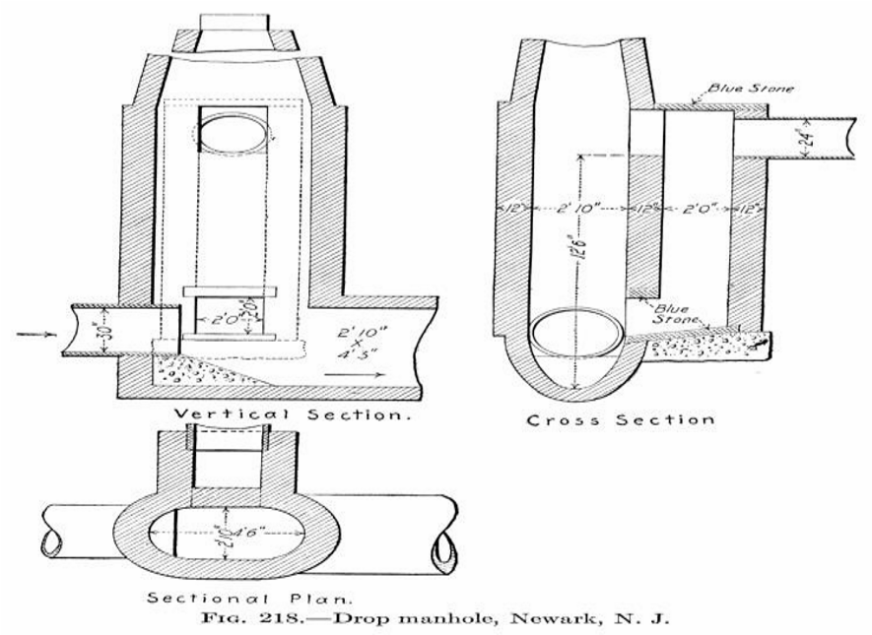

# **Flushing Tanks**

In flat ground for branch sewers, when it is not possible to obtain self -cleansing velocity at all flows, due to very little flow, it is necessary to incorporate flushing device. This is achieved by making grooves at intervals of 45 to 50 m in the main drains in which wooden planks are inserted and water is allowed to head up. When the planks are removed, the water will rush with high velocity facilitating cleaning of the sewers. Alternatively, flushing can be carried out by using water from overhead water tank through pipes and flushing hydrants or through fire hydrants or tankers and hose.

Flushing manholes are provided at the head of the sewers. Sufficient velocity shall be imparted in the sewer to wash away the deposited solids.

1. **Inverted Siphon**

An inverted siphon or depressed sewer is a sewer that runs full under gravity flow at a pressure in the sewer. Inverted siphons are used to pass under obstacles such as buried pipes, subways, etc. As the inverted siphon requires considerable attention for maintenance, it should be used only where other means of passing an obstacle in line of the sewer are impracticable.

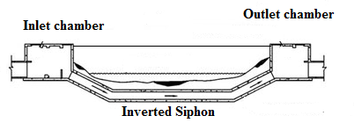

Figure: Inverted siphon

1. **Storm Water Inlets**

Storm water inlets are provided to admit the surface runoff to the sewers. These are classified in three major groups.

1. Curb inlets
2. Gutter inlets
3. Combined inlets.

They are located by the sides of roads, the inlets are so located that the storm water is collected in a short period and there is no flooding or accumulation of huge quantity of storm water on the roads. The structure of the inlet is constructed with brickwork with cast iron grating at the opening confirming to IS 5961.

**Curb Inlet:** These are vertical opening in the road curbs through which storm water flow enters the storm water drains. These are preferred where heavy traffic is anticipated.

**Gutter Inlets:** These are horizontal openings in the gutter which is covered by one or more grating through which storm water is admitted.

**Combined Inlets:** In this, the curb and gutter inlet both are provided to act as a single unit. Gutter inlet is normally placed right in front of the curb inlets.

 

1. **Clean-Out**

It is a pipe which is connected to the underground sewer. The other end of the clean-out pipe is brought up to ground level and a cover is placed at ground level.

A clean-out is generally provided at the upper end of lateral sewers in place of manholes. During blockage of pipe, the cover is taken out and water is forced through the clean-out pipe to lateral sewers to remove obstacles in the sewer line. For large obstacles, flexible rod may be inserted through the clean-out pipe and moved forward and backward to remove such obstacle.



Fig. clean-out pipe

**HOUSE DRAINAGE PLUMBING SYSTEMS**

**Water Supply System**

A home’s water supply system routes municipal water from the street to your house, where it branches out to deliver the water to faucets, showers, toilets, bathtubs, and appliances such as the water heater, dishwasher, and washing machine.

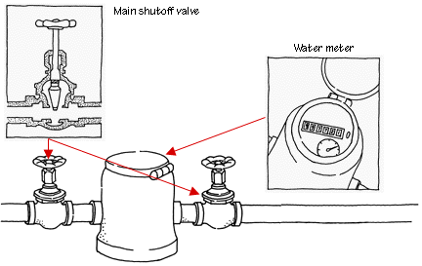

**Water System Meter & Valve**

The equipment for this delivery and distribution is essentially a system of water pipes, fittings, service valves, and faucets. These pipes and other fittings are commonly made of plastic, copper, or galvanized iron. The pipes range in diameter from 1/2 inch to 4 inches or more.

**Drain-Waste-Vent System**

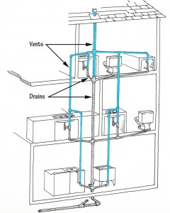

Typical Vents & Drains in Home Plumbing

Though it isn’t one of the most glamorous parts of a house, the drain-waste-vent (DWV) system is one of the most crucial. The job of the drain-waste part of the system is to carry waste water and sewage from sinks, bathtubs, showers, toilets, and water-using appliances such as dishwashers and washing machines and deliver those wastes to the septic tank or public sewer.

The vent system—part of the plumbing that is usually less well known to most homeowners—is connected to the drain-waste piping, and its job is to ventilate sewage gases so they don’t build up in the house. The vent system also helps drainpipes maintain the right pressure for proper drainage.

The pipes of the DWV system are usually out of sight, hidden in the walls, beneath the floors, and in the attic. But when the system ceases to do its job properly, it is hardly out of mind. Clogged drains are among the most common problems that occur in a DWV system.

**Kitchen Plumbing System**

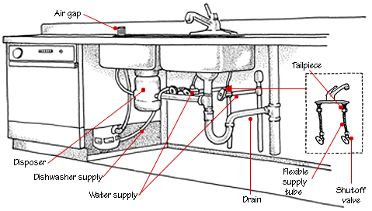

Kitchen Sink Plumbing Diagram

Most kitchens have a fairly simple plumbing setup that includes hot and cold water supply lines to the faucets; a waste line for the sink (or sinks); and, for kitchens with a gas range, a gas supply pipe. Many kitchens also have hookups for a dishwasher, disposer, ice maker, and/or instant hot water, but these are generally tied in to the sink’s plumbing.

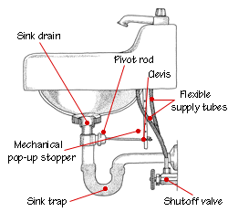

Bathroom Sink Plumbing Diagram

**Bathroom Plumbing System**

Sinks, showers, bathtubs, and toilets, bathrooms are all about plumbing. The plumbing in a bathroom must handle water delivery to and waste removal from all of these fixtures in an organized, efficient, leak-free manner.

Two plumbing systems are needed to handle a bathroom’s plumbing needs: water supply and drain-waste-vent.

Water supply plumbing delivers hot and cold water to the sinks, tub, toilet, and shower. This system originates at the municipal supply or other fresh water source, goes through the meter, and is delivered to the house. At the water heater, it splits into two lines—one that carries cold water and the other that delivers hot water from the water heater to the fixtures that require it.

The drain-waste-vent system collects waste water from fixtures and waste from toilets and delivers them to the sewer or septic system. Near each of the sinks, tubs, showers, and toilets, vent pipes exhaust sewer gases up and out the roof and provide air pressure so wastes can flow freely.